Make the background of the hero section (including the banner) Black.

Change the colour of the writing to **#5A6E22**

**Remove the photo of the guy leaving the job interview and leave that space blank**

**Replace my logo with this please (keep the name CareerFrame, but make it white)** 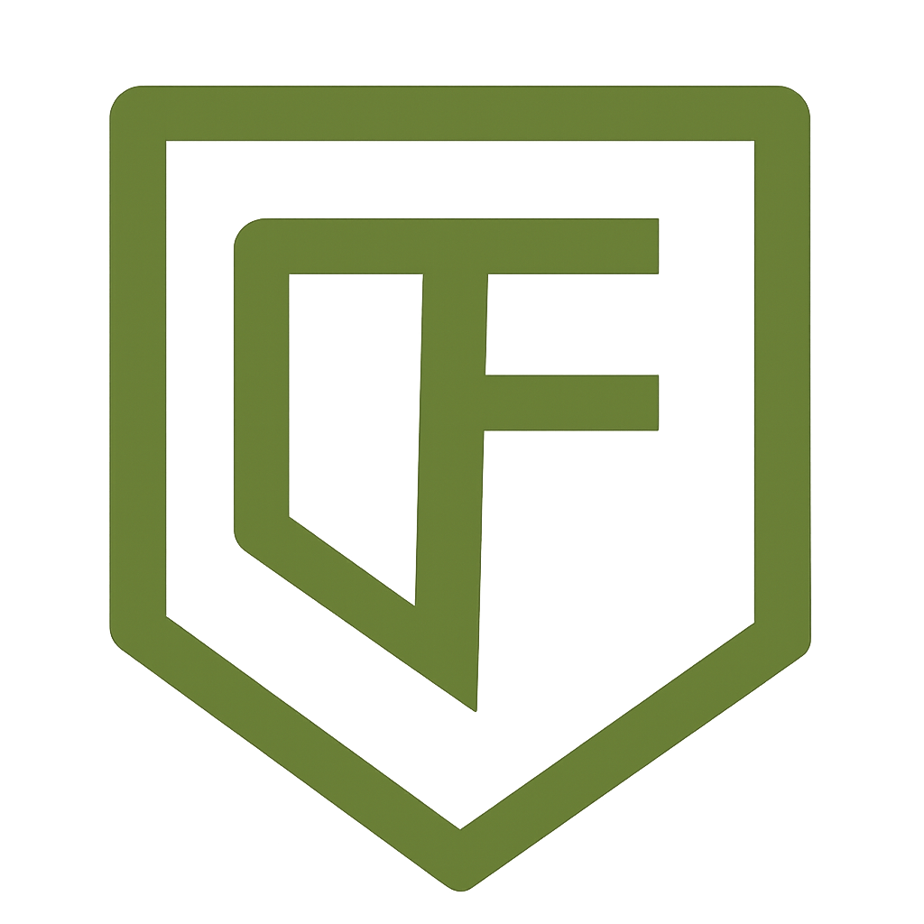

**On the ‘What to expect after you sign up page’ remove the clock & Day 1, clock and day 2, clock and day 3**

**Replace “**Join 12,000+ professionals who've transformed their careers in just 15 minutes a day Average salary increases: 31% 92% land new role within 90 days” With “Join early adopters shaping the future of personalised career growth — your transformation could start with just 15 minutes a day. - We’re targeting meaningful career progress, including salary growth, by aligning you to roles that match your potential - Our AI coach is built to fast-track your journey to a new role — with a milestone system designed for results in under 90 days.  
  
**Replace the originals with the alternatives shown below – these are from the real success from real people section**🔧 ORIGINAL:

12,000+ Successful Career Transitions  
Professionals who landed their dream jobs

✅ ALTERNATIVE:

Built to support 12,000+ future success stories  
CareerFrame was created to help people land the roles they deserve — and you're next.

**💡 Title**:  
**72%**  
**Reported Improved Career Confidence**  
After creating a personalised roadmap with CareerFrame potential.

🔧 ORIGINAL:

4.8/5 User Satisfaction Rating  
Based on 2,400+ verified reviews

✅ ALTERNATIVE:

*(Or add a placeholder)*  
Be the first to rate us — your voice matters.

🔧 ORIGINAL:

92% Success Rate  
Land new role within 90 days

✅ ALTERNATIVE:

Our goal: career breakthroughs in 90 days  
CareerFrame is built for speed — helping you move fast with a clear, achievable plan.

🔧 ORIGINAL:

Real Success Stories from Real People  
And then: 3 case studies with job titles, employers, salary increases, quotes.

✅ ALTERNATIVE:

1. Replace with forward-looking aspirational quotes

(e.g. anonymous quotes from *beta users*, or future-facing user types)

Real Stories — Coming Soon  
We're currently working with early adopters who are transforming their careers. Be among the first to write the next success story.